The Why (problem)
AIM Statement
Team Lead (Dept.) |  | Team Members (Dept.)
Start Date: DD/MM/YYYY Last Updated: DD/MM/YYYY – JHC Completion Date: DD/MM/YYYY

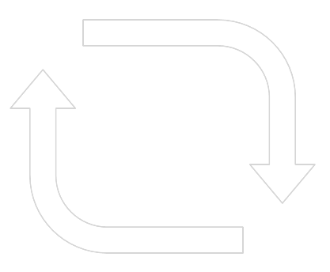  PLAN | DO
 | STUDY
 | ACT

